
FRIENDS OF WARRNAMBOOL
BOTANIC GARDENS
A0032902E

Issue No. 46 Summer 2007
NEWSLETTER

REPORT FROM THE PRESIDENT

Christmas Drinks
All members are invited to join us for the annual Christmas drinks in the rotunda at the Warrnambool Gardens on Friday 7th December at 5.30pm. We shall acknowledge Terry O'Sullivan's 20 years in the gardens. We shall also rejoice in the acquisition of John Sheely as a very well credentialed and enthusiastic curator of the Warrnambool Botanic Gardens.
We wish all our friends a very happy Christmas and New Year.

Funding for the Fernery Roof.
We are delighted to announce that after much persistence by our committee, especially Mandy King and Pat Varley, the Friends of the Gardens has received notification of a grant from Victorian Heritage Grants to restore the fernery.

Anne Lynch

CURATORS REPORT

As summer fast approaches the team is busy finalising our annual plantings.

Work progresses on the restoration of Bed 16 with one large self-sown Pittosporum undulatum (Sweet Pittosporum) to be removed before new plantings are undertaken.

Work on Bed 15 has commenced with inappropriate plant material being removed.

The new picnic tables and chairs are a HUGE success with extensive use being seen during the week.

The extension to the bore line has commenced with approximately 300 metres of pipe being laid to allow access to water towards the northern boundary. This extension will assist greatly with any new plantings and further enhance existing trees.

The plant material propagated at the last FOWBG activity is all looking healthy with several cuttings already producing new growth.

We are in the process of finalising a visit to WBG from the teams at Geelong, Colac and Ballarat. It is hoped to host an informal day at the WBG where the other teams can provide input and assistance to our garden and its management.

In closing all the staff at WBG would like to wish the FOWBG all the best for Christmas and we look forward to continuing to work positively together in 2008.

Cheers,
John Sheely, Ros and Mark

LIFE IN THE GARDENS

Learning is Fun in the Gardens

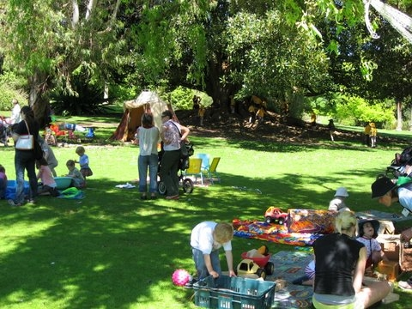
On a glorious spring morning, Thursday 15th November, the Dip Child Care students from TAFE again organised and supervised an activity day for pre schoolers in the Gardens.
Dozens of tiny tots were joined by eighty prep grade children from Warrnambool Primary School for stories creative activities and games.

The Garden Club of Casterton

The Friends enjoyed the opportunity to show a group of garden lovers around the Gardens on November 19th. There were 33 members of the Casterton Garden Club who joined us for morning tea, a talk and a tour. Thanks to Judy Loch and Pat Varley who were our guides for the day while Anne Lynch and Mandy King served tea and coffee and the traditional fruit cake made by Mandy.

Picnic Tables

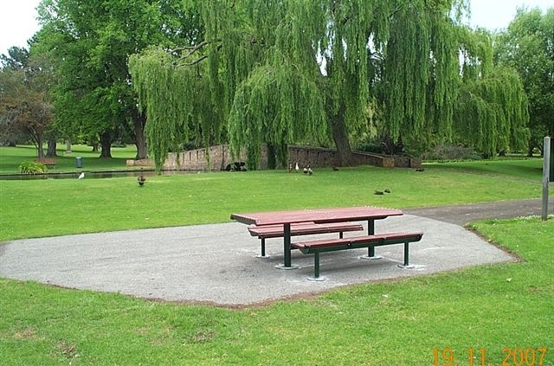
There has been a lot of activity in November and we are delighted that two picnic settings are now in place to the north of the lake. They are designed and located to provide ready access for people with limited mobility. They are the gift of Isobel and David Jones on behalf of the F. J. Foundation, for which we are most grateful. Their installation has been managed by the Gardens Staff and they provide a great addition to the Gardens.

Wild Life

The bats having returned to the gardens some six months ago are still hanging around. They camp in the Canary Island palms near the fernery - about 60 of them and are a point of interest for visitors.
Another visiting crowd in the form of a swarm of bees descended on the rotunda, ensuring that it was given a wide berth during their habitation.
Did you know there are fish in the lake, and at least one tortoise?

Closure of Cockman Street

The Friends have been made aware of a proposal to close Cockman Street. We are opposed to closure of the street as it would restrict access to the gardens. It would also require a turning circle that would impact on the triangle of pines, require the removal of the gas lamp and bring traffic dangerously close to the main gates. A group of three mature Norfolk Island Pines in the triangular traffic island at the Cockman Street/Jamieson Street intersection provides a landmark at the main entrance and makes a visual link between the trees of the gardens and the distinctive row of Norfolk Island Pines in Jamieson Street. MP1995. We understand that there must be community consultation before any street is closed.

The Fernery

The fernery has been closed to the public for some months now due to the rotting and dropping timber slats making up the roof.
The Minister for Planning made funding available for ‘Victoria’s Heritage: Strengthening our Communities’. The friends as usual are always on the lookout to gain funding for restoration works within the gardens. After researching the amount of work that was needed and gaining support from the WCC, the forms were filled out and posted with hope. To our surprise we were selected as worthy under the criteria ‘The program funds projects to repair, conserve and interpret heritage places and objects of importance to the community’. We are so excited that we are now able to make major and much needed repairs to the fernery. We can un-chain those beautiful gates enabling visitors to view and enjoy our very special collection of Otway Ferns. The ferns have been lovingly compiled and planted by Marigold Curtis and Lorraine Depler.

An Idea Put Forward By A Member Of The Friends

Many of us have books on gardening we no longer use on our bookshelves. If you are thinking of recycling them we suggest that you run them past John Sheely at the Gardens or a member of the Committee. Useful material could be retained for reference, and the remainder passed on to second hand book dealers

Christmas Celebrations – At The Rotunda

The Friends of Warrnambool Botanic Gardens invite you to join them for Christmas drinks in the Gardens
at 5.30 on Friday December 7.
We will acknowledge the work of our Curators and the generous contributions of our supporters

Invitation enclosed

BOTANIC GARDENS AUSTRALIA NEW ZEALAND

The Colac Otway Shire hosted a regional meeting of the Botanic Gardens of Australia and New Zealand BGANZ on 16th November.
Dr Greg Moore, University of Melbourne was the keynote speaker. His dynamic and thought provoking address on climate change challenged some of the beliefs/myths that relate to trees, parks and gardens.
Dr Moore stressed that almost without exception, the scientific community accept there is and will be a change in world climate, although they argue vigorously as to the extent of that change. He predicted that our rainfall will be more intense with storms and heavy rain. Storm water drains will be unable to cope with the run off and flooding will result.
He stressed that plants are not just decorative – they have real economic value. Plants hold water in the canopy and take up water in their roots. Lawns grass and other permeable surfaces reduce runoff. Without plant cover floods and erosion intensify.
Plants also sequester large quantities of carbon. By his conservative calculations, a mature tree would store more than 10 tons of carbon.
He asked if we felt guilty when using water on our gardens. About 9% of Victoria’s water is used on parks and gardens. Gardens are a soft option in comparison with industry, but they are significant in our economy. We have a right to defend our parks and gardens.
Botanic gardens have a special role. They demonstrate performance of native and exotic species over time, providing research and educational material, seed sources for the future and stock plants for industry. They have large old plant populations and they sequester large quantities of carbon. With their contribution to preservation and conservation they are our inheritance.
Other speakers focussed on ‘putting botanic gardens on the tourism radar’, noting that nature based tourism was growing at 20% a year. BGANZ have established a working group to promote our network of gardens.
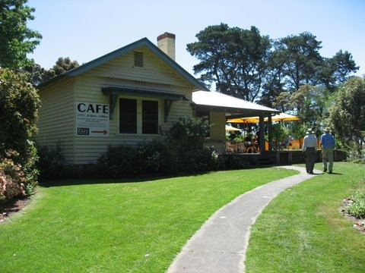
The program concluded with a walk through the Colac Gardens led by Laurence Towers. The Gardens were gazetted in 1865 and occupy12 hectares to the south of Lake Colac. Their early design was influenced by Daniel Bunce, and later by William Guilfoyle. They are the home of some magnificent old trees five of which are on the register of significant trees. An automated watering system, funded by the Shire and Community Water Grants has just been installed while the Botanic Café and Gallery operate from the Curators Cottage.
At the end of an inspiring day we were convinced there would be great value in hosting a similar conference in the City of Warrnambool in 2008.

Pat Varley and Mandy King

THE GROWING FRIENDS
Activities at the Gardens on the first Wednesday of the month have to date provided the opportunity for Friends to learn about planting and propagating a range of plants. The next session on December 5th at 10.30 will be held at the Sherwood Park campus of TAFE.
Please let Mandy or John know if you can attend.

NOT TO BE MISSED

As you know John Sheely and his staff are now conducting regular garden days for the members. Each one is different but always held on the 1st Wednesday of the month. This month’s session will be held at the Sherwood Park Campus of TAFE at 10.30am December the 5th.

We would appreciate your feed back. Is this a good day for you, if not we would love to hear from you as we are keen to make this a popular event for as many of our members as possible.
As usual email or call us with your thoughts and input.
*************

Mrs Donald’s Christmas Cake

½ lb sultanas and raisins . ¼ lb mixed peel and currants and chopped almonds
2 oz cherries. 4 eggs. ½ lb butter. 10 oz plain flour. ¼ lb white and brown sugar
½ baking powder. ½ tsp mixed spice and nutmeg.
4 tbsp brandy whisky or sherry

Line an 18 inch tin with a double thickness of brown paper 1 inch above the level of tin.
Prepare fruit the day before – chop it small and sprinkle it with1/2 the brandy or sherry.
Beat butter and sugar to a cream, add eggs one at a time and beat well.
Add ½ the chopped fruit, then the remainder of the brandy, then half the sifted flour and spices and finally the remainder of the fruit and flour.
Bake 3 -31/2 hours in a moderate to cool oven

***************************

NEWSLETTER DELIVERY
A few people have taken up this option.
If you would like to received your next newsletter by email contact me on aking@eftel.net.au
Mandy King

FRIENDS OF WARRNAMBOOL
BOTANIC GARDENS Inc.
A0032902E

President
Anne Lynch (03) 5562 1303

Vice-president
Pat Varley (03) 5562 4800

Secretary
Mandy King (03) 55620343

Asst. Secretary
Laurel Myers (03) 55617571

Treasurer
Kathy Wicherson (03) 5562 1436

Growing Friends
Judi Phillips (03) 5562 3320

Guided Tours
Isobel Jones (03) 5568 1076

Newsletter Editor
Marigold Curtis (03) 5567 6316

Historian
Marie Johnstone (03) 5562 3238

Archives
Jean Fitzpatrick (03) 5562 3447

Public Officer
Billie Rowley (03) 55611583

Correspondence:
Friends of Warrnambool Botanic Gardens Inc.
P.O. Box 1190
Warrnambool 3280

Email: aking@eftel.net.au

Our newsletter is published spring, summer,
autumn and winter.

If you would like to contribute to our publication
please forward material to the above address.

Membership: Payable at/or by the AGM
July 2007

November 2007

